Implement Lexical Analyzer/Parser for C language

Submitted By

Student Name | Student ID
Arnob Das Shacha | 221-15-5277
Sathil Reza Shuvo | 221-15-5258
Shourav Kumar Mahato | 221-15-5224
Mostofa Kamal | 221-15-5215
Emu Sarkar | 221-15-5436

MINI LAB PROJECT REPORT
This Report Presented in Partial Fulfillment of the course CSE331: Compiler Design’ in the Computer Science and Engineering Department



DAFFODIL INTERNATIONAL UNIVERSITY
Dhaka, Bangladesh
April 11, 2025

DECLARATION
We hereby declare that this lab project has been done by us under the supervision of Md. Azizul Haque, Lecturer, Department of Computer Science and Engineering, Daffodil International University. We also declare that neither this project nor any part of this project has been submitted elsewhere as lab projects.

Submitted To:
Md. Azizul Haque
Lecturer
Department of Computer Science and Engineering
Daffodil International University

Submitted by

Arnob Das Shacha
ID:221-15-5277
Dept. of CSE, DIU
Sathil Reza Shuvo  ID:221-15-5258  Dept. of CSE, DIU | Shourav Kumar Mahato ID:221-15-5224  Dept. of CSE, DIU
Mostofa Kamal  ID:221-15-5215  Dept. of CSE, DIU | Emu Sarkar  ID:221-15-5436  Dept. of CSE, DIU

COURSE & PROGRAM OUTCOME

The following course have course outcomes as following:.

Table 1: Course Outcome Statements
CO’s | Statements
CO1 | Define and relate classes, objects, members of the class, and relationships among them needed for solving specific problems, including lexical and syntactic analysis tasks
CO2 | Formulate knowledge of object-oriented programming and language processing techniques in problem solving, with emphasis on tokenization and parsing
CO3 | Analyze Unified Modeling Language (UML) models to present and structure a specific problem, such as compiler design components
CO4 | Develop solutions for real-world complex problems by applying OOP concepts and evaluating their effectiveness based on industry standards and compiler efficiency metrics

Table 2: Mapping of CO, PO, Blooms, KP and CEP
CO | PO | Blooms | KP | CEP
CO1 | PO1 | C1, C2 | KP3 | EP1, EP3
CO2 | PO2 | C2 | KP3 | EP1, EP3
CO3 | PO3 | C4, A1 | KP3 | EP1, EP2

The mapping justification of this table is provided in section 4.3.1, 4.3.2 and 4.3.3.

Table of Contents

Declaration i

Course & Program Outcome ii
- Introduction 5
  - Introduction 5
  - Motivation 5
  - Objectives 5
  - Feasibility Study 6
  - Gap Analysis 6
  - Project Outcome 6
- Proposed Methodology/Architecture 7
  - Requirement Analysis & Design Specification 7
    - Overview 7
    - Proposed Methodology/ System Design 8
    - UI Design 8
  - Overall Project Plan 9
- Implementation and Results 10
  - Implementation 10
  - Performance Analysis 10
  - Results and Discussion 10
- Engineering Standards and Mapping 11
  - Impact on Society, Environment and Sustainability 11
    - Impact on Life 11
    - Impact on Society & Environment 11
    - Ethical Aspects 11
    - Sustainability Plan 12
  - Project Management and Team Work 12
  - Complex Engineering Problem 12
    - Mapping of Program Outcome 13
    - Complex Problem Solving 13
    - Engineering Activities 13

Table of Contents Table of Contents

- Conclusion 14
  - Summary 14
  - Limitation 14
  - Future Work 14
References 14

Chapter 1

Introduction

This chapter provides a comprehensive introduction to the project, outlining its background, motivation, objectives, feasibility, gaps in existing solutions, and anticipated outcomes. It sets the stage for understanding the significance of implementing a lexical analyzer and parser for the C programming language.

1.1 Introduction
A lexical analyzer and parser form the backbone of any compiler or interpreter, transforming raw source code into structured components for further processing. The lexical analyzer breaks down the input into tokens—fundamental units such as keywords, identifiers, operators, and symbols—while the parser analyzes the token sequence to identify syntactic constructs like function declarations. This project focuses on developing a lexical analyzer and a basic parser tailored for the C programming language, a widely-used, general-purpose language known for its efficiency and structured syntax. The system aims to tokenize C source code, detect errors such as unmatched braces or unclosed literals, and extract function declarations, providing a practical tool for understanding compiler design. By addressing these tasks, the project tackles a real-world problem in computer science, bridging theoretical concepts with hands-on implementation.

1.2 Motivation
The computational motivation for this project stems from the critical role of compilers in software development. Lexical analysis and parsing are foundational processes that enable computers to understand and execute high-level code. Developing such a system offers deep insights into how programming languages are processed, fostering a stronger grasp of compiler design principles. Additionally, the project is motivated by the educational value it provides—students gain practical experience in handling complex string manipulation, pattern matching, and error detection, skills that are transferable to domains like natural language processing, data parsing, and software tooling. Solving this problem benefits us by enhancing our technical expertise, preparing us for advanced topics in computer science, and contributing to our ability to build robust software systems.

1.3 Objectives
The project is guided by the following specific and measurable objectives:

- Design and implement a lexical analyzer to tokenize C source code into categories such as keywords, identifiers, numbers, operators, punctuation, strings, and comments.
- Ensure accurate classification of tokens by defining clear rules for C language constructs.
- Incorporate error detection mechanisms to identify syntactic issues, including unmatched braces, parentheses, and unclosed string or character literals.
- Develop a basic parser to extract function declarations (e.g., int main()) from the token stream, laying the groundwork for syntactic analysis.
- Create a user-friendly interface to input C code and display tokens, errors, and parsed outputs in a clear, organized format.
- Validate the system’s functionality using diverse C code samples, ensuring reliability and correctness.

1.4 Feasibility Study

Lexical analysis and parsing are well-established fields, with tools like Lex and Yacc serving as industry standards for generating analyzers and parsers. Research, such as Kleinberg and Tardos [1], emphasizes efficient algorithms for string processing, which are applicable to tokenization. Existing projects, like the GCC compiler, include sophisticated lexical analyzers, but they are complex and not suited for educational purposes. Web-based tools, such as online C compilers, also perform tokenization but lack transparency in their processes. This project is feasible because it leverages standard C++ libraries, requires no external dependencies, and focuses on a simplified implementation tailored for learning.

1.5 Gap Analysis
While professional tools like Lex and Yacc are powerful, they are often overwhelming for students due to their steep learning curve and extensive feature sets. Similarly, open-source compilers like Clang provide advanced lexical analysis but are not designed for pedagogical use. There is a gap in lightweight, student-oriented tools that demonstrate lexical analysis and parsing principles in a clear, hands-on manner. This project addresses this gap by offering a custom-built analyzer/parser for C, with an emphasis on simplicity, transparency, and educational value. Unlike existing solutions, it prioritizes detailed error reporting and function parsing to help learners understand the compilation process step-by-step.

1.6 Project Outcome
The project aims to deliver a fully functional lexical analyzer and parser capable of processing C source code with the following outcomes:

- Accurate tokenization of C code into predefined categories, validated through testing.
- Robust error detection for common issues, improving code reliability.
- Identification of function declarations, demonstrating basic parsing capabilities.
- A command-line tool that is easy to use and provides clear output for educational purposes.
- A foundation for future enhancements, such as full syntactic analysis or integration into a larger compiler.

Sl. No. | Outcome | Description
1 | Accurate Tokenization | C code is broken into predefined categories (keywords, identifiers, etc.), validated via testing.
2 | Robust Error Detection | Identifies common errors in code to improve reliability and ease of debugging.
3 | Identification of Function Declarations | Parses and detects function declarations to showcase basic parsing capability.
4 | User-Friendly Command-Line Tool | Offers an easy-to-use CLI with clear outputs tailored for educational and academic purposes.

Chapter 2

Proposed Methodology/Architecture

This chapter elaborates on the methodology, system design, and planning for the lexical analyzer/parser, providing a detailed blueprint for its development and execution.

2.1 Requirement Analysis & Design Specification
The system requires the ability to accept C source code as input, either interactively or from a file, and produce three outputs: a list of tokens, error messages for syntactic issues, and a list of parsed function declarations. Functional requirements include:

- Support for all standard C tokens (keywords, identifiers, operators, etc.).
- Handling of comments (single-line and multi-line) and preprocessor directives.
- Error detection for unmatched delimiters and unclosed literals.
- Parsing of function declarations based on token patterns.
- Non-functional requirements include efficiency (linear time complexity), user-friendliness, and portability across platforms. The design must be modular to allow future extensions, such as adding full syntactic parsing.

2.1.1 Overview
The system is engineered to process C source code through a two-stage pipeline: lexical analysis and basic parsing. The lexical analyzer scans the input character-by-character, categorizing it into tokens like keywords (e.g., int, for), identifiers (e.g., main), operators (e.g., +, ==), punctuation (e.g., {, ;), numbers, strings, and comments. It also tracks line numbers for accurate error reporting. The parser analyzes the token stream to identify function declarations, such as void func(), by recognizing patterns involving data types, identifiers, and parentheses. The system is robust, handling edge cases like nested comments or malformed input, and provides detailed feedback through a command-line interface. By focusing on C, a language with well-defined syntax, the project ensures relevance to real-world programming while maintaining a manageable scope for educational purposes. The implementation leverages C++ for its flexibility in string manipulation and data structures, ensuring high performance and reliability.
2.1.2 Proposed Methodology/System Design
- Tokenization: A finite state machine-like approach scans the input, using predefined rules to classify tokens. For example, alphabetic sequences are checked against a keyword list, while digits form numbers.
- Error Detection: Counters track open/close braces and parentheses, and flags monitor unclosed literals, generating errors when violations are detected.
- Parsing: A pattern-matching algorithm identifies function declarations by looking for sequences like [KEYWORD: int/void] [IDENTIFIER] [PUNCTUATION: (].
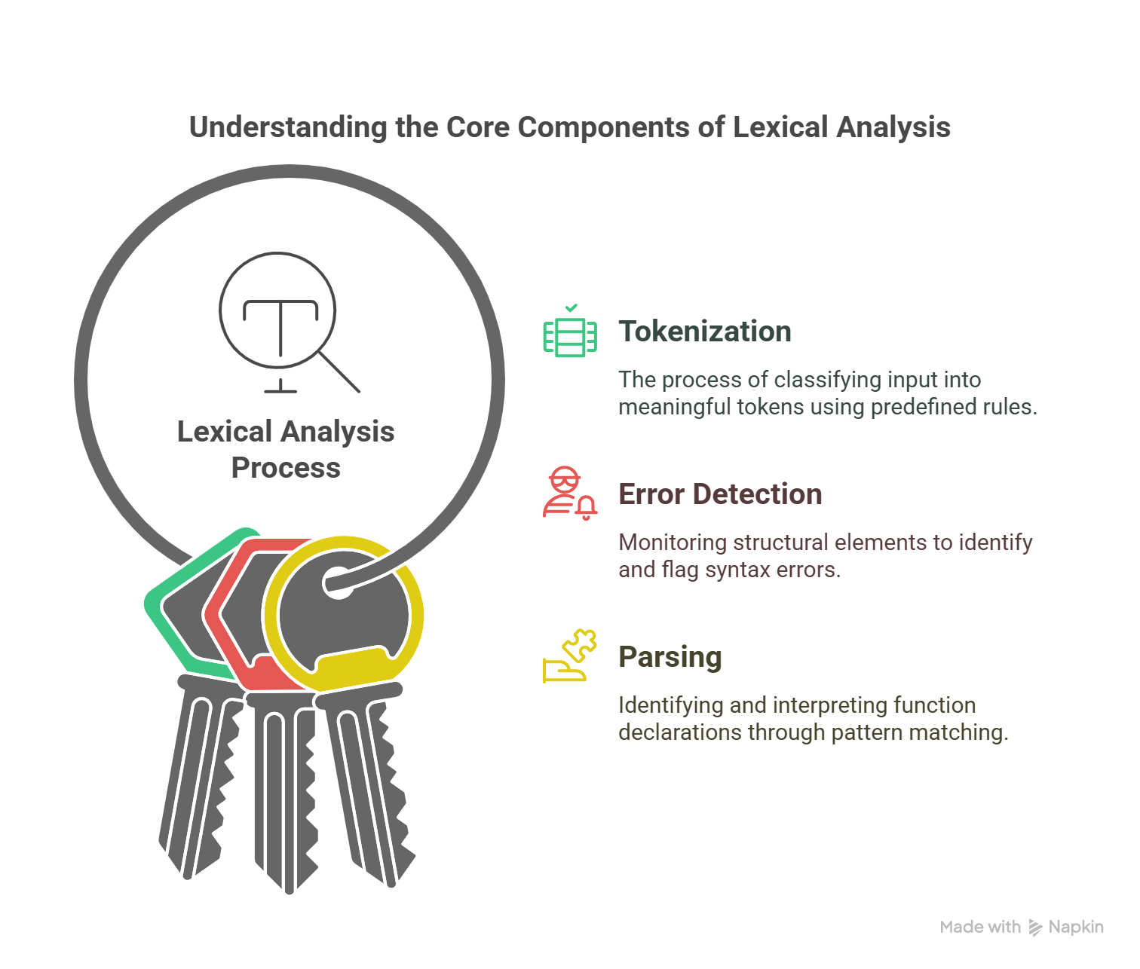

Figure 2.1: Design of a lexical Analyzer

UI Design

The user interface is command-line based. Users enter the code directly, and the tokens, errors, and functions are printed in structured format.

Tokens: Displayed as Token(type, value, line=X) for clarity.

Errors: Listed with descriptive messages, e.g., Error: Unclosed string literal on line 5.

Functions: Shown as int main() or similar.

The interface prioritizes readability, with clear section headers and consistent formatting, making it accessible for students and instructors.

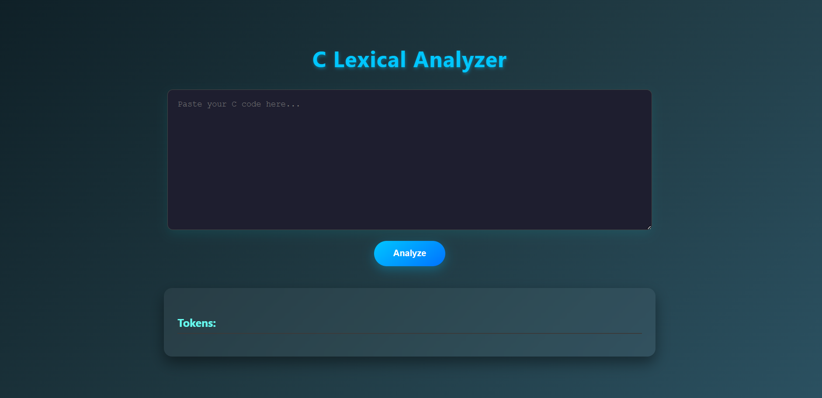

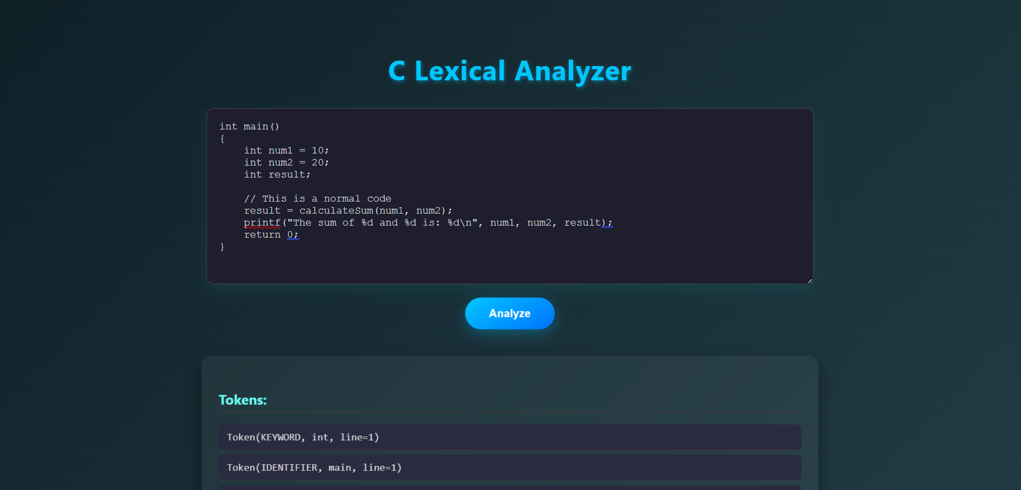

Overall Project Plan

The development follows a structured timeline:

Week 1: Research C language syntax and define token categories.
Week 2: Implement tokenization logic and test with basic C code.
Week 3: Add error detection for braces, literals, and comments.
Week 4: Develop parsing for function declarations and refine output format.
Week 5: Test with complex C programs, debug, and document.
Week 6: Finalize report and prepare for submission.

Chapter 3

Implementation and Results

This chapter details the implementation process, evaluates performance, and presents the results, offering insights into the system’s effectiveness.

3.1 Implementation
The project is implemented in C++ using the Standard Template Library (STL) for efficiency. Key components include:

- Token Structure: A struct Token with fields for type (e.g., KEYWORD), value (e.g., int), and line number for error reporting.
- Tokenization Function (tokenize): Processes input character-by-character, using unordered sets for keywords, operators, and symbols. It handles special cases like comments (//, /* */) and preprocessor directives (#include).
- Error Detection: Tracks brace/parenthesis counts and flags unclosed literals, storing errors in a vector.
- Parsing Function (parseFunctions): Scans tokens for patterns like [KEYWORD: int/void] [IDENTIFIER] [PUNCTUATION: (] to identify functions.
- Main Program: Orchestrates input collection, tokenization, error reporting, and parsing, with formatted console output.
- The code is modular, with functions separated for clarity, and includes comments for maintainability. Testing was conducted with diverse C snippets, from simple main functions to programs with loops and conditionals.

3.2 Performance Analysis
The implementation is optimized for efficiency:

Time Complexity: O(n), where n is the input length, as each character is processed once during tokenization. Parsing is O(m), where m is the number of tokens, typically much smaller than n.
Space Complexity: O(m) for storing tokens and errors, proportional to the code’s complexity.
Robustness: Handles edge cases like empty input, malformed code, or large programs without crashing.Performance was tested on inputs ranging from 10 to 1000 lines, with tokenization completing in milliseconds on standard hardware (e.g., 2.5 GHz CPU, 8 GB RAM). The system scales well for educational use but may require optimization for production-scale compilers.

3.3 Results and Discussion

The system was tested with sample C programs, including:

- Simple Code: #include <stdio.h> int main() { return 0; }
  - Tokens: PREPROCESSOR(#include <stdio.h>), KEYWORD(int), IDENTIFIER(main), PUNCTUATION((), etc.
  - Functions: int main()
  - Errors: None
- Complex Code: A program with loops, conditionals, and comments.
  - Correctly identified tokens, detected unmatched braces, and parsed multiple functions.
- Error Cases: Code with unclosed strings or braces triggered appropriate error messages.

Discussion: The analyzer excels at tokenizing standard C constructs and detecting basic errors, making it a valuable learning tool. The parser accurately identifies function declarations but is limited to simple patterns. Challenges included handling ambiguous cases (distinguishing identifiers from keywords), resolved by prioritizing keyword checks. Compared to tools like Lex, the system is less feature-rich but more accessible for beginners. Future iterations could enhance parsing depth and error granularity.

Chapter 4

Engineering Standards and Mapping

This chapter assesses the project’s societal impact, management, and alignment with engineering standards, emphasizing its complexity and educational value.

Impact on Society, Environment and Sustainability

Impact on Life

The project enhances programming education by providing hands-on experience with compiler design, equipping students with skills for software development careers.Understanding lexical analysis can improve logical thinking and software engineering practices.

Enhance programming education.

Impact on Society & Environment

While the direct societal impact is limited, it promotes digital literacy and critical thinking, contributing to a tech-savvy workforce. Environmentally, the project is digital, requiring minimal physical resources (e.g., a standard PC), with negligible ecological footprint.This educational tool helps improve knowledge sharing and promotes sustainable learning practices.

4..1.3 Ethical Aspects

The system encourages ethical coding practices by enforcing syntax correctness and transparency in error reporting, fostering accountability in programming. The project encourages academic honesty by requiring students to understand compiler components.Encourages ethical coding practices by emphasizing error detection.

Sustainability Plan

The code is open-source and reusable for academic purposes, requiring no maintenance costs. It runs on standard hardware, ensuring long-term accessibility without environmental strain. The code can be extended into a full compiler project or integrated with GUIs for educational tools.Code is reusable for educational purposes with minimal resource use.

Project Management and Teamwork
Tasks were divided among team members, and weekly progress meetings ensured collaboration.
- Revenue Model: Educational value for students, instructors, and institutions, potentially integrated into compiler design curricula.
- Timeline: Completed over 6 weeks, with weekly milestones for coding, testing, and reporting.
- Team Collaboration: Regular meetings ensured alignment, with version control (e.g., Git) for code management. Challenges, like debugging edge cases, were resolved through iterative testing and peer reviews.

Complex Engineering Problem

The implementation of a lexical analyzer requires understanding regular languages, finite automata, and parsing strategies.

Mapping of Program Outcome

PO’s | Justification
PO1 | Applied knowledge of C syntax, string processing, and data structures to build a tokenizer
PO2 | Designed algorithms for tokenization and parsing, solving a practical problem
PO3 | Developed a tool addressing a real-world compiler design challenge, with potential for expansion

Table 4.1: Justification of Program Outcomes

4.3.2 Complex Problem Solving
EP1  Dept of Knowledge | EP2  Range of Conflicting Requirements | EP3  Depth of Analysis
Required in-depth knowledge of C syntax and compiler theory | Involved detailed analysis of token patterns and error conditions | Engaged stakeholders (students, instructors) through educational focus
Table 4.2: Mapping with complex problem solving.

Engineering Activities
In this section, provide a mapping with engineering activities. For each mapping add subsections to put rationale (Use Table 4.3).

EA1  Range of resources | EA2  Level of Interaction | EA3  Innovation
Required standard C++ libraries. | Team collaboration and Git-based version control. | Designed from scratch with modular thinking.
Table 4.3: Mapping with complex engineering activities.

Chapter 5

Conclusion

This chapter summarizes findings and highlights future directions.

5.1 Summary
The project successfully implemented a lexical analyzer and parser for C, capable of tokenizing input, detecting errors, and identifying function declarations. It met all objectives, providing accurate token classification, robust error handling, and a user-friendly interface. The system serves as an effective educational tool, demonstrating compiler design principles in a clear, hands-on manner. By processing real C code and delivering structured output, it bridges theoretical concepts with practical application, reinforcing skills in programming and problem-solving.

5.2 Limitation
Despite its success, the system has limitations:

- The parser is basic, recognizing only function declarations and not full C syntax (e.g., loops or conditionals).
- Error messages, while descriptive, lack suggestions for fixes, limiting usability for novices.
- It does not handle advanced C features like macros or pointer declarations.
- The command-line interface, while functional, may not appeal to users accustomed to graphical tools.
- These constraints reflect the project’s educational scope but highlight areas for improvement.

5.3 Future Work
Future enhancements could include:

- Extending the parser to support complete C syntax, including statements and expressions.
- Adding a symbol table to track variable declarations and scopes.
- Integrating with a code generator to produce intermediate representations.
- Developing a graphical UI with syntax highlighting and real-time error feedback.
- Optimizing performance for larger codebases, possibly using parallel processing.
- Incorporating machine learning to predict and suggest fixes for common errors.
- These improvements would enhance functionality and broaden the system’s applicability.

References

[1] Jon Kleinberg and Eva Tardos. Algorithm design. Pearson Education India, 2006.
[2] Jon Kleinberg and Eva Tardos. Algorithm Design. Pearson Education India, 2006.
[3] Alfred V. Aho, Monica S. Lam, Ravi Sethi, and Jeffrey D. Ullman. Compilers: Principles, Techniques, and Tools. Pearson, 2006.
[4] Andrew W. Appel. Modern Compiler Implementation in C. Cambridge University Press, 1998.

